DANGERS OF THE CUTEREBRA FLY (BOTFLY)
It tunneled through my Bichon’s brain!
Vickie Halstead RN, CVNS, CLNC

Owners of cats and dogs need to be aware of the dangers of the cuterebra fly, AKA botfly. My champion Bichons enjoy a very sheltered life mostly in the house, on my deck or the dog run, and seldom on the grass. If this could happen to my dogs, it could happen to any dog if you live in North or South America. Cats are also at risk, with a higher incidence than dogs.

On a hot day in August 2014, my Bichons were basking in the sun on my deck, barking intermittently at people in my yard, playing, and all acting normal. Perhaps 15 minutes elapsed when we discovered one of my dogs lying on her side on the landing of the deck below 10 stairs. She was almost unconscious, bleeding from her right nostril, and drooling foamy saliva from her mouth. I grabbed her and quickly transported her to the emergency vet clinic. She was close to death with a loss of her swallow and gag reflexes (indicates brain damage), increasing the risk for aspiration of oral fluids into the lungs that could cause breathing problems and pneumonia. They started an IV, drew blood samples for testing, and gave her oxygen. Her eyes would open but she was not reactive to her environment and was not moving.

Her name is Quiche, AKC Champion Petit Ami’s Non-de-Plum, imported from Petit Ami kennel in Norway. She is 5 years old, an AKC champion, and produced 2 lovely litters. Quiche was a very lively, sweet, and healthy Bichon Frise—until now….

Quiche at age 2 years being shown to her championship

Signs of brain damage

Being an ER nurse, I considered this to be a critical event and she may need to be euthanized. I took her to Affiliated Emergency Veterinary Service in Blaine, MN where she spent the first night in ICU and received incredible care. I transported her the next day to another clinic for access to a neurologist and an MRI scanner.

Our first suspicions were that she suffered head trauma from falling down the stairs and/or a seizure. Her blood tests were all normal indicating no cause for a loss of balance or a seizure; no further seizures, which ruled out an initial seizure; and her vital signs were normal on oxygen. She maintained a posture of a tight circle to the left with her head and neck, a sign of brain damage. The techs lovingly called her the pretzel dog!

Her overnight stay in the ICU revealed small improvements—moving slightly, and the return of gag and swallow reflexes. They gave her IV antibiotics to treat possible aspiration and a medication to decrease brain swelling. Her blank stare persisted, not recognizing humans or me when I visited her; she was blind in her right eye; possibly deaf; and still not attempting to stand.

Euthanasia was still a consideration.

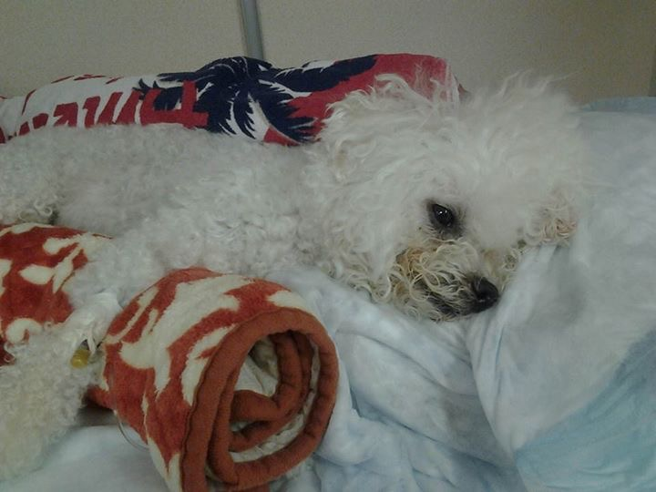
A few hours after the incident: in ICU with oxygen piped into kennel, IV in right front leg, and positioned on left side to unwind her tight head and neck tilt to the left.
The next day Quiche’s MRI showed a tract (tunnel) through her brain on the right side starting from the frontal lobe of the brain (forehead area) and ending in the brainstem (back of the brain) that controls breathing and vital signs. The MRI also revealed inflammation in the right nostril of her nose and right sinuses, and no signs of head trauma. Blood tests and spinal tap were normal.

The neurologist, Dr. Christina Wolf, did a superb job of caring for Quiche with the help of the ICU techs at Blue Pearl in Eden Prairie, MN, where she spent 5 days in ICU. Dr. Wolf diagnosed Quiche with cerebral cuterebriasis, brain infestation of the larva of the cuterebra fly, scientific name for the botfly. The theory is that Quiche sniffed a botfly egg into her nose that hatched into a larva, evidenced by the initial bleeding from her right nostril and the inflammation of the right nostril and sinuses per the MRI scan. Then it burrowed through the roof of her mouth into her brain, and quickly tunneled through her brain. It's truly creepy!

We suspect she collapsed due to the brain injury, doubtful that she fell down any stairs. High doses of steroids were added to her medications, antibiotics were continued to prevent brain infection, and an injection of Ivermectin was given to kill the larva in case it was still alive since it was close to her spinal cord. Euthanasia was still a consideration.

The cuterebra fly, also known as the botfly

The suspect fly is cuterebra, AKA botfly that exists in North and South America and is a large bee-like fly. It lays eggs in late summer primarily in grass near rodent or rabbit burrows and sometimes in rocks. The eggs need a warm host to hatch and to develop into larvae, also called warbles. The larvae become parasites in mammals. The common hosts are rabbits, rodents, cows, deer, horses; less commonly dogs and cats; and rarely humans. The eggs enter the hosts through body orifices such as nose, mouth, eyes, or skin wounds. After penetration the larvae migrate to an area under the skin where they break through the skin and form breathing holes. The larvae travel through the host via the brain, spinal cord, lungs, throat, gastrointestinal tract, or skin. They live in the skin lesions for 1-2 months and drop off in the early stage of a fly. Veterinarians usually find the larvae in lesions on the skin.

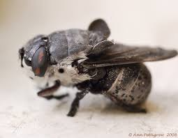
An example of a cuterebra fly, scientific name for the botfly

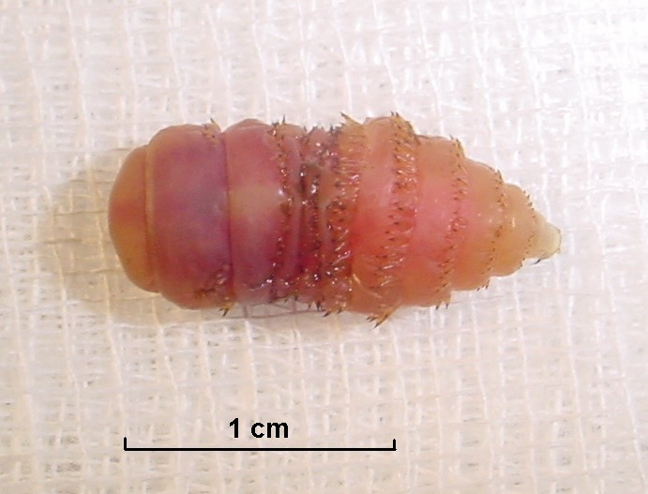
A larva from a cuterebra fly (botfly)

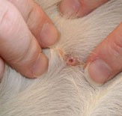
Cuterebra skin lesion

Five days in ICU

When I visited Quiche while she was slowly making progress in the ICU over 5 days, she did not recognize me which made visits difficult and emotional. She was making attempts to stand; holding her head up; continuing to tightly tilt her head and neck to the left; starting to respond to humans; and was still blind in her right eye. They began to hand feed her and she was drinking water. After they removed her urinary catheter, she was able to pee and poop outside in the grass with the aid of a harness to support her torso to prevent her from falling over.

Optimism now.

The day I took Quiche home was awesome! With the aid of the harness, Dr. Wolf had Quiche standing on a rug. I squatted to her level; she took a couple of steps; she wagged her tail for the first time; and she gave me some kisses. She recognized me! At that time I knew that every penny of the thousands of dollars I spent was worth it.

Optimism abounding, but not sure about her quality of life.

Quiche went home on high doses of steroids (prednisone), which were tapered off over a period of about 3 weeks. I was fearful that she would deteriorate after the steroids were completed, but she continued to improve. In addition to her prednisone and antibiotics, I added probiotics and a regime twice a day of giving her therapeutic-grade essential oils including lavender, lemon, heilchyrsum, cypress, brain power, aroma life, clary sage, valor and frankincense. These were applied via diffusion or topically to the skin or pads of her feet, chosen due to their effect on brain function and in fighting inflammation and infection.

On the mend

Quiche is a miracle! Dr. Wolf informed me that dog brains are capable of healing quickly, which I’ve witnessed first hand. Nearly 3 months since the injury, Quiche has continued to gradually recover to my estimate of 90% of her baseline. When she came home she was walking in circles with the aid of the harness. Now she walks well, sometimes in a slight diagonal line, runs and bounces, plays with the other dogs, goes up and down stairs, and is back to being happy and very friendly to people. She compensates well for a slight weakness in her right front leg. Rarely her balance is slightly off. She has head tilt to the right when you talk to her, a sign of brain injury in dogs, but it’s very cute. Her hearing is intact and she regained her eyesight in the right eye! In addition, her cognition seems to be back to normal—she is back to being smart and mischievous, and still rings the bell to go outside. I am so amazed at her progress!

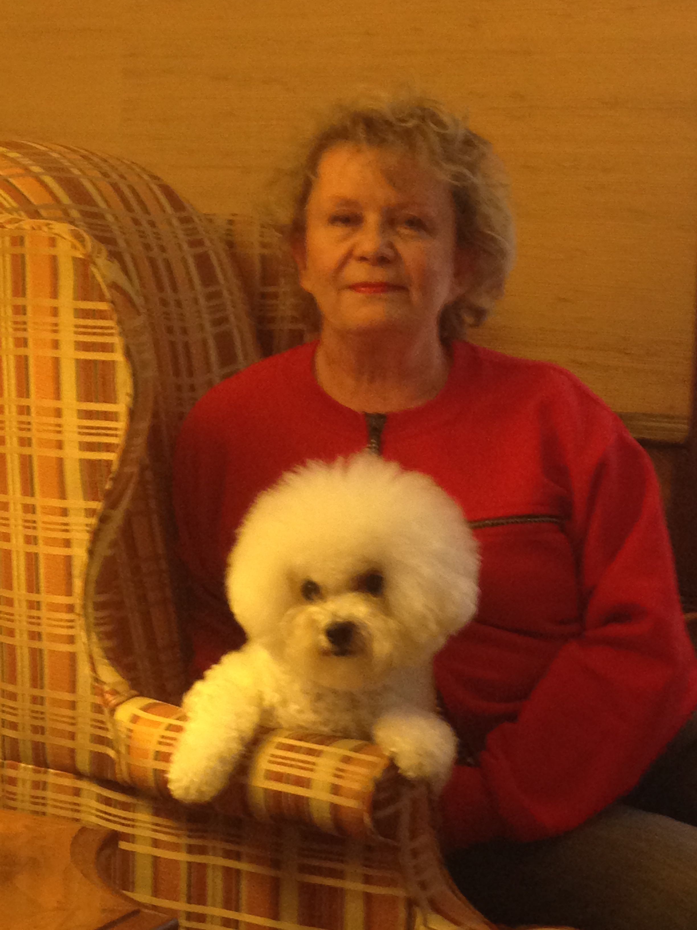
She will enjoy a very quality life. Vickie with Quiche 3 months after her brain injury:
Quiche's care has demanded a lot of my time, advantageous for her that I'm a nurse. She has become very spoiled and is more affectionate than before the injury. In addition to conventional veterinarian treatment and expedient emergency care, I believe the essential oils had an impact on her recovery. Aromatherapy is now accepted therapy in hospitals, Emergency Departments, long term care facilities, and hospice units for treatment of pain, anxiety, nausea, as well as other issues. I continue Quiche’s essential oil program.

Prevention

Lastly, the question is prevention. Dogs and cats are at risk if they have access to areas with numerous rodents, rabbits, and rodent burrows. The pets at highest risk are low to the ground (cats and short-legged dogs) and terrier breeds that go to ground to kill rodents in burrows. Measures of prevention include:

- When walking on a leash, keep your dog close to you and avoid areas of rodent burrows.
- Keep your cats in the house.
- Prevent your dogs from hunting rodents.
- Deter flies by daily picking up feces in dog runs.
- Frequently wash rocks or surfaces in dog runs in case cuterebra eggs were deposited there.
- Watch for bleeding or irritation in the nose that might indicate presence of the eggs or larvae.
- Inspect the skin of your dogs or cats for cuterebra lesions. If found, see your veterinarian.
- Use more caution outdoors if your pet has any skin wounds or sores where the cuterebra eggs can enter the body.

Update: Quiche’s 12th birthday, June 29, 2021

At almost 7 years since Quiche’s brain injury, she continues to live the good life despite some health issues in the interim. Shortly after the incident she developed considerable skin issues to the point of being almost bald with multiple lesions. I was aware she was at risk for skin issues after receiving so many medications such as steroids and the Ivermectin. After a year of treatment, it finally resolved and never resurfaced. Treatment included changing to a totally raw diet, essential oils, acupuncture, Chinese herbs, and dermatology prescribed medications for fungal and bacterial skin infections. At that time, she was diagnosed with breast cancer. The tiny tumor was removed, and she was spayed without complications.

In 2017, 3 years after her brain injury, for fun and to demonstrate her progress I showed her as a special at a dog show. Per the judge he almost gave her a best of breed win because of her beauty, how happy she was to be back in the show ring, and her beautiful side movement but he did not like her movement away from and toward him. Her mild residual weakness in her left legs changed her gait. He was shocked when I shared her story with him.

Now in 2021 she is 12 years old, very content, plays less, sleeps more, eats her raw diet well, and no health or skin issues since 2016. In my opinion she seems like an older dog than her age, but I suspect her ordeal aged her. Maybe she will reach the average life span age for Bichons of 15! I will continue to give her more love and care than she requires! I am now retired from nursing, but continue healing primarily dogs via energy work, encouraged by the experience of caring for Quiche.

Quiche relaxing, observing, and enjoying being present at a dog show in 2019.

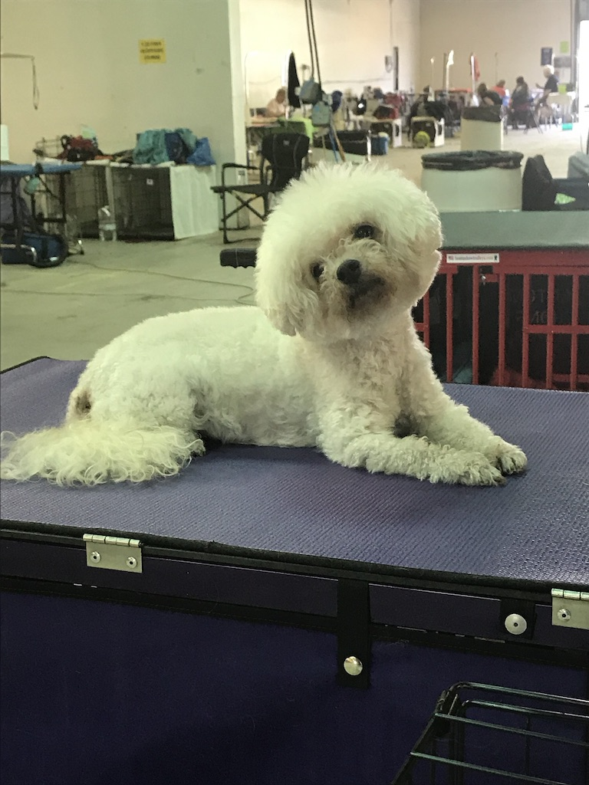

Vickie Halstead RN, CVNS, CLNC, HTA-2, Reiki Master has been actively involved in breeding and showing Bichons Frises since 1990, producing 35 litters and >50 AKC champions, one of which achieved Best in Show at the 2005 Bichon national specialty. She has been a member of the Bichon Frise Club of America (BFCA) since 1997, a member of BFCA’s Health Committee since 2001 & chairwoman 2003-2010, plus was a member of the Board of Directors of BFCA 2005-2007. She published articles in the Bichon Frise Reporter, dog magazines, newspapers, and on www.bichonhealth.org. Vickie purchased her first Portuguese Water Dog in 2017 who recently had her first litter. She is a member of the Portuguese Water Dog Club of America (PWDCA) and its health committee since 2018. Vickie has been practicing as a Registered Nurse since 1973, retired in 2017 after previous experience in ICU, flight nursing, ER for 25 years, legal nurse consultant, speaker for nursing classes/seminars, and lastly as a Coumadin (blood thinner) Nurse at a clinic (continues per diem). Currently she operates a healing service primarily for dogs, but also humans, that offers energy healing (reiki, healing touch), essential oils, and aromatherapy.
https://www.victoireshealingandbreeding.com

